Name of Student: Husam Nour | PRN:2507012286
Semester: III | Year : AY 2026-27
Subject: Programming with Java
ASSIGNMENT No : 19
TITLE : JDBC SELECT Operation
Problem Statement
Develop a Java application to establish connectivity with a database and perform data retrieval using the SELECT operation.
Learning Objectives
To establish database connectivity and retrieve records using JDBC SELECT statements.

Programme
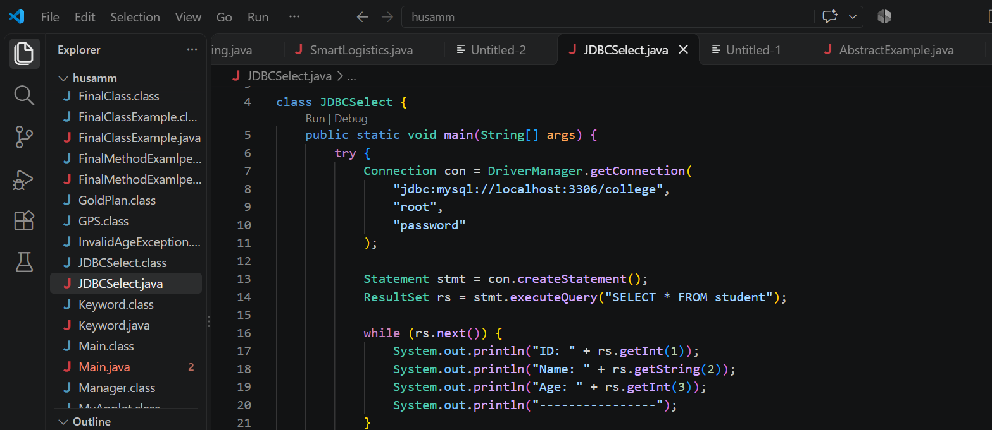
Output
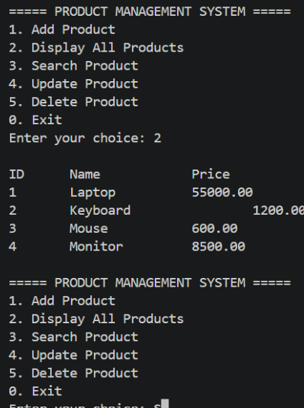
Exercise
- Create a Java application to display student recordsfrom database using SELECT query.
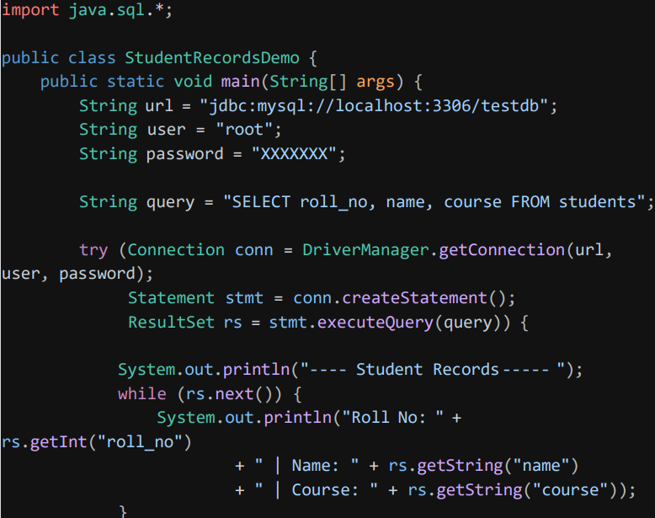
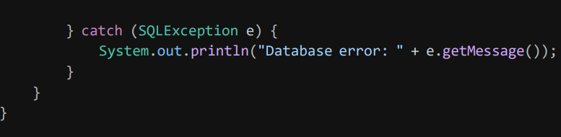
Output
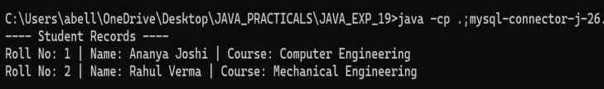
- Create a Java application that connects to a database and displays product details using SELECT query. Show product ID, product name, quantity, and price.
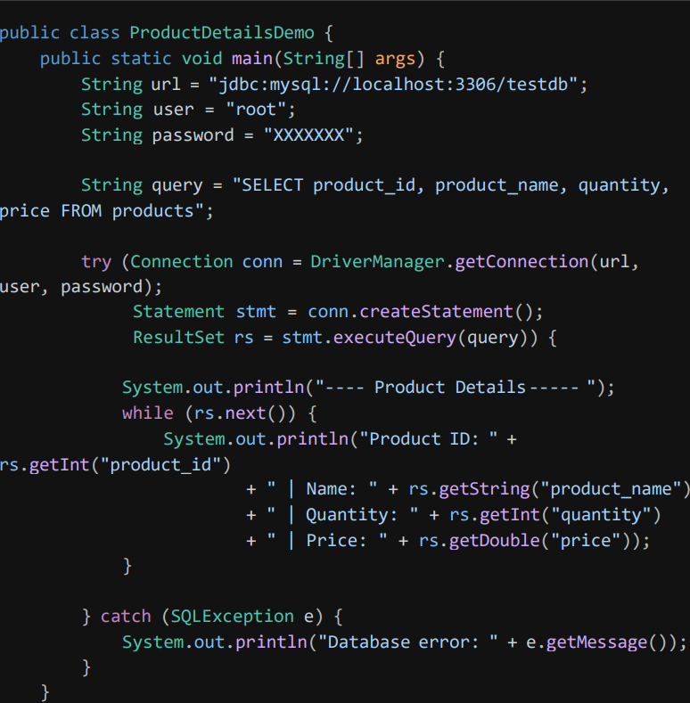
Output
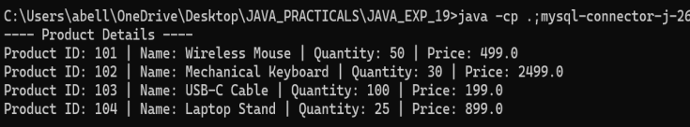
Conclusion
Thus, the JDBC SELECT operation was successfully implemented in Java to establish database connectivity and retrieve records from the database using the SELECT statement. The retrieved records were displayed on the console successfully.

